|  |  |
| --- | --- |
| **DOKUMENTASI EKSTERNAL**  External Documentation |  |
| **[PROYEK]**  **[ *Project*]** |
| **MATAKULIAH < COMP 6176 > – < Human and Computer Interaction >**  ***Human and Computer Interaction*** |
| SEMESTER [GENAP] 2019/2020 ***[Evet] Semester Year2019/2020*** |

## Judul Proyek

## Xtream Chaser

## Pendahuluan

# Information about the game :

Fighting game between 2 people facing each other with a time of 1 minute in 3 rounds which will determine the winner within 1 minute the player can hit each other and issue moves according to each character. Player can fight player or computer with different difficulties.

Character 1

Allucard

   Allucard coming from a race of undead also known as Dracula. He was having lot of fun doing battles and duel, in this peaceful world that just got united. He did not know on what to do and someday he hear a rumour about an arena battle where you can duel and fight with al kind of races from all over the world. He races himself and join the arena himself.

   His fighting style is with a sword where he parries all attack that is coming to him and try to get a counterattack. While he might have low defence capabilities, he is nimble and able to run around the arena while use his special power to turn into a bat to get away from sticky situation.

Character 2

Butterfly

   Butterfly is her code name from the family. She is coming from a noble family and the youngest from the family. She trains day and night to be able to help in the war to gain her own fame but did not quite make it as the world become peaceful. As she eager to gain her own fame and glory she joins the Xtream Chaser and try to be the best to prove the family she also can be useful

  She has balance fighting style between her defence and attack. She uses a sword and magic for her attack and defences by striking and imbuing magic to herself to enchant her feat while healing herself for holding a longer battle. With the ability to use magic she can block easily projectile with a force field she created Infront of her to dash forward to her foe.

Character 3

Roxie

  Roxie is a mage human wo have train hard to impress her master. One day her master asks her to join the Xtream Chaser to prove her training is she ready to go on an adventure and learn the mysteries of the world herself.

  Roxie have a mafic elemental of fire that she can control at will. She might be slow on her feet but able to make a barrier for herself while teleport around the arena to get away from the enemies. With her ultimate calling rain of fireball from the sky to shower at her foe.

Character 4

Errol

                Errol is an elf. He used to be peaceful and love everything around him. He was also loved by all the villager in her village. One day the village was attack by a person he cannot really remember his face, but he has a single horn on his forehead and totally destroy everyone in front of him and killed every person that he loved. He was left alone as he was hiding in the forest because he was gathering some herbs to make some healing for his sister. He was so enraged of himself and the killer his rage calls the demon and he make a contract on heat that make his other arm becoming a half demon. As he travels alone in searching of the killer, he found Xtream Chaser and try to join to find some information of the killer

                Errol have demon power while also the power f the nature around him. He able to move swiftly while attack with his morphing hand. While attacking his collecting power from the nature and the fear of his foe to use it on his ultimate. Where he become a full demon and able to move faster and attack way harder

Character 5

Lauriel

                Lauriel a kind girl who enjoy peace with a family that she loves. She has the power of water that she can control. She train with the book that she read from the library and train it after the chores she have, but one day he mother for ill and with the family doesn’t rally have money she cant give the medication that her mother need. She kept on looking for a job and find Xtream Chaser as participant can gain money when they won the battle and so she decided to join the arena to help her mother.

                Lauriel is a mage with water elemental. She is swift and able to move around the arena by skiing on her water magic while attacking her opponent. She can freely manipulate water into a whip, sword, even spike to attack her foe. With enough energy she can turn the water into ice as her ultimate. Making her slower but stopping her foe in place

Character 6

Maloch

                Maloch is a demon with an embodiment of a Bull. He loves chaos and always constant on looking for it. He attacks village and random adventure as he enjoys the thrill that he got. As the time comes, he attracts attention to the authority and was capture for it. He was given a chance by joining the Xtream Chaser to gain his glory while still in jail nonetheless he accepted because if he able to fight he do not mind at all.

                Maloch might seem like does not have an arm but he able to use his dark power to act as his arm. He is a brute that will charge at his opponent and do not care how badly he is hurt in the process. As his ultimate he flies into the sky and dive to the ground with the dark power that he has collected while battling. As he landed the land will shake and energy will spit out from the ground.

# Lore game :

Couple Garden

Facing a world beyond our imagination, a place full of trees and valleys like a fairytale chaser story don't be too happy to play and forget our important mission! Because, according to information, we must move quickly. A bigger new threat will come later, so does this have something to do with the evil plan (the name of the enemy)? Since a long time ago in the couple garden center there was a mysterious forest that few people knew about. This time our journey will begin soon, and we will all work together to explore this mysterious world

Couple Garden a place where couple goes for their first date or also their last date? It might look lovely but be careful sometime in the wrong time spores might sprout out and make everyone aggressive. At this moment of time everyone tries to attack each other. And so, this place become a perfect ground to start your duel. Try to defeat your foes but also not hurting the civilian.

Dungeon Battle Arena

Your classic arena where Xtream Chaser started. You fight your e=way to the top to gain your fame, gain, and glory. This arena is quite small compare to the rest so your movement might be restricted but as long as the crowd like it who really cares.

From time to time in the colosseum the place of very fierce warfare to become the strongest power holder who wins will be the king of the area. Come on Xtream chaser show your strength and conquer this colosseum!

Dead city

The Dead City the city of the dead. This place is filthy, foul bad with lot of mindless Undead creature but sometime a duel needs to be special right? So with this arena we prepare a special magic item where you can see from the city while enjoying the battle, but for you duelist be careful sometime who grabs you are not just your foe but also something else you don’t want to see

The loneliest city in this country because of the large number of monsters in this map scares new players, let's go xtream chaser defeat all the monsters and pk players so that it's not quiet anymore .

Lovely garden

The East is famous for its soil fertility, and its inhabitants live in peace and peace. All that cannot be separated from the cold hand of the ruling power at that time, the power had succeeded in changing the economic conditions of its people, who had almost all the population below the poverty line, now can sleep soundly without feeling hungry at all.

Do not let the name fool you, because lovely Garden are filled with nasty flora while you battle here you need to watch out with multiple debuff that the element are giving to you ranging from bleeding, poison, and many more that the plant can inflict to you. Use this to your advantages and knock the enemies to the fauna to help you out in the duel, hey it’s not cheating its strategy.

Starry night

This is the place where you duel the champion and become your own champion. This place is just beautiful and there won’t be any dangerous trap laying around. Its just pure skill between you and the enemy. Make sure you reach your highest skill before challenging the champion of Xtream Chaser and makes this place your playground

## Dokumentasi

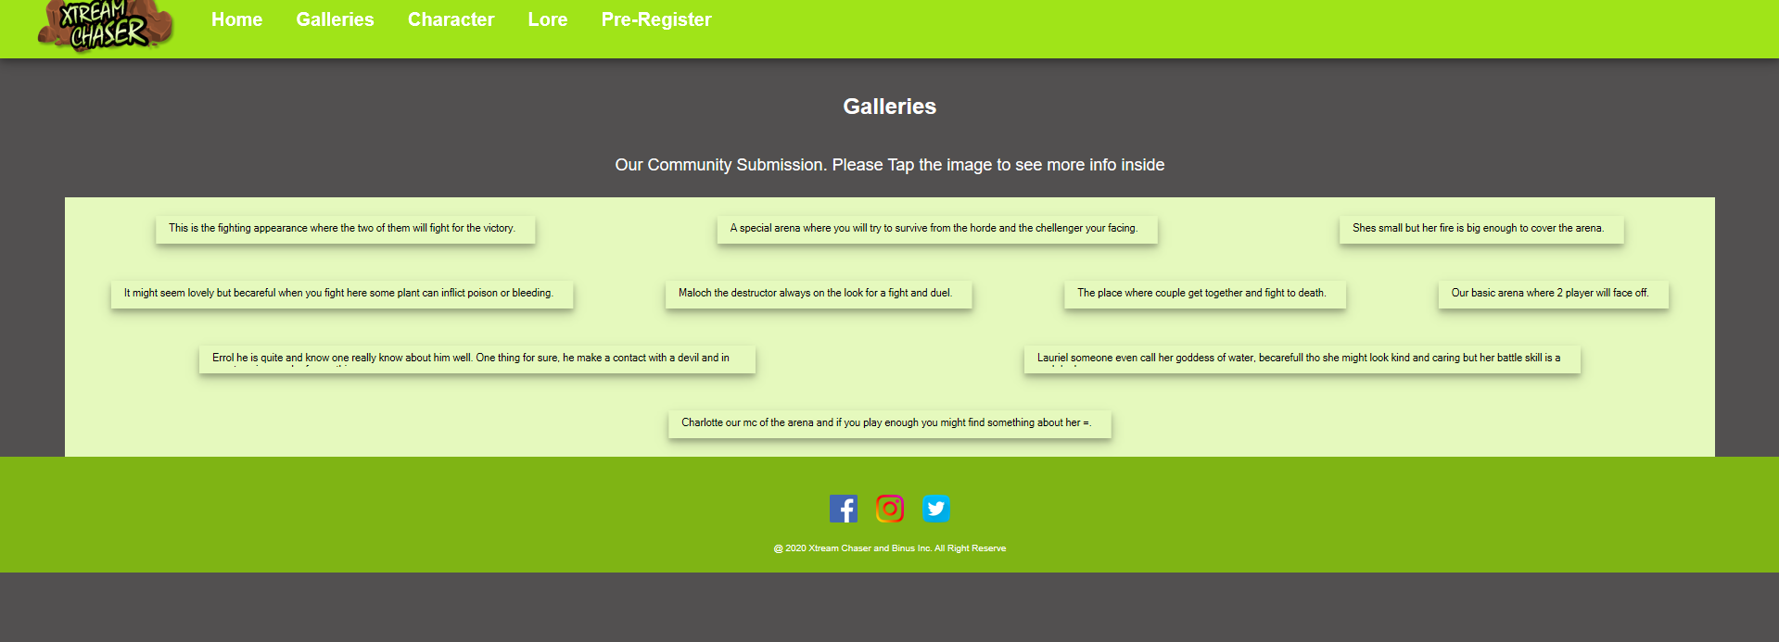

The galleries section shows comments about people who play this game.

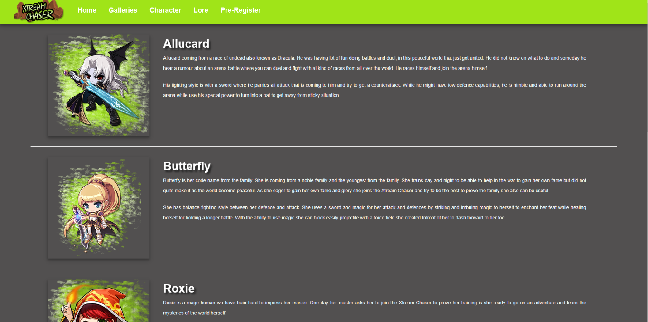

The character button when clicked will display the heroes in the game with the character's story.

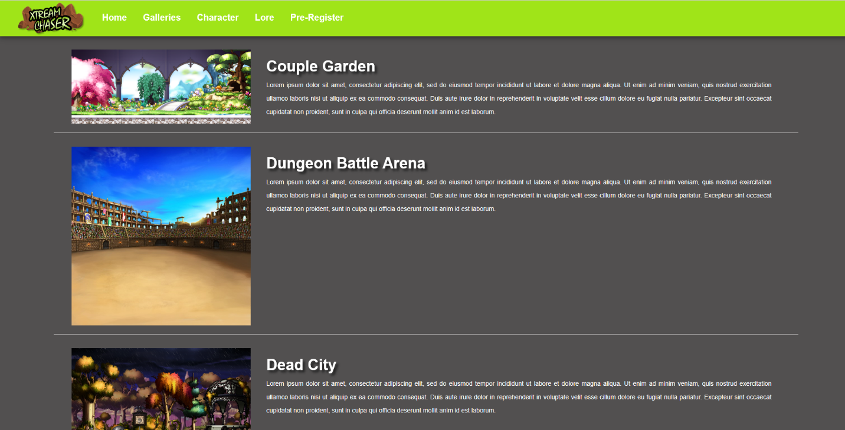

In the lore when clicked it will display a story about the arena on the game.



In the pre register or join section will enter the register menu to register a new account for the first time playing this game where people have to fill in their name, password, retype their password, email, and address.

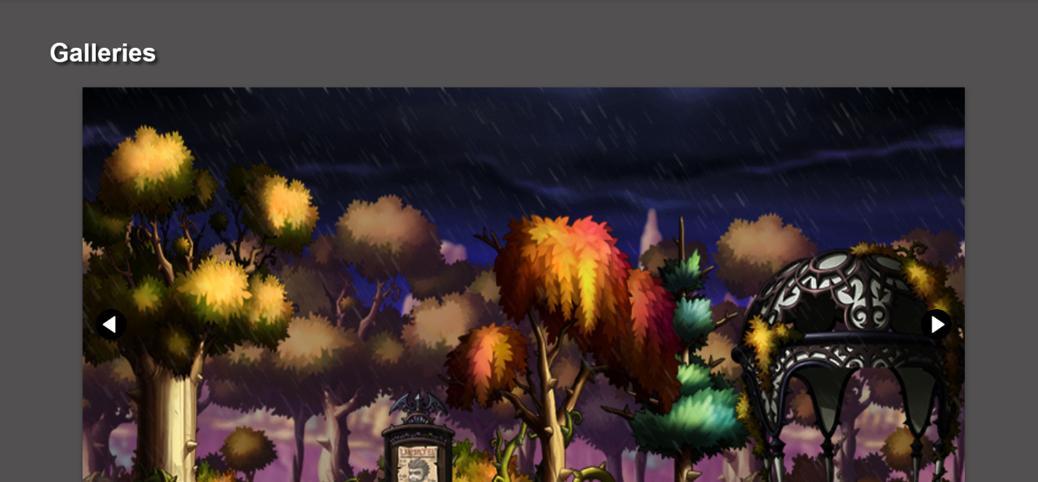

At the bottom of the home there is a picture - a picture of the game.

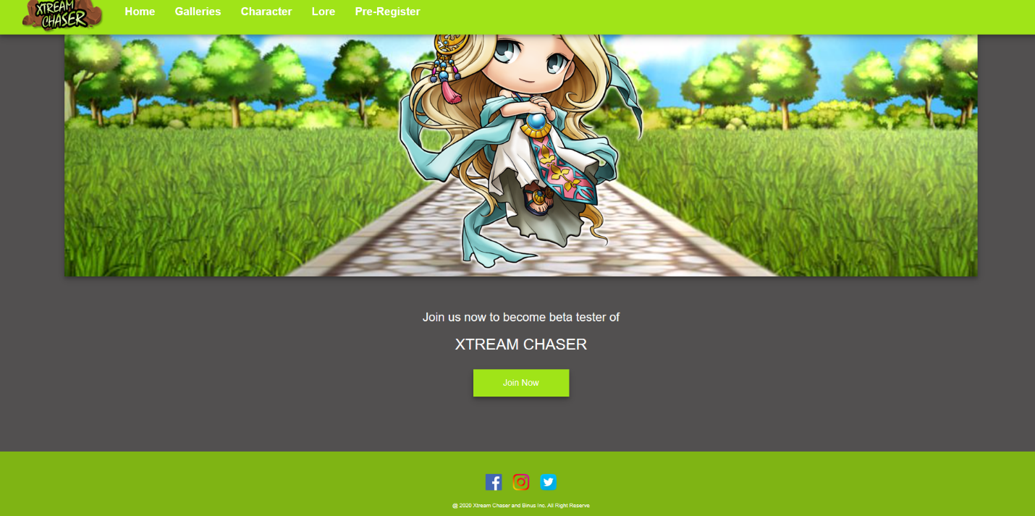

## At the bottom of the home there is also a social media button from the xtream chaser itself.

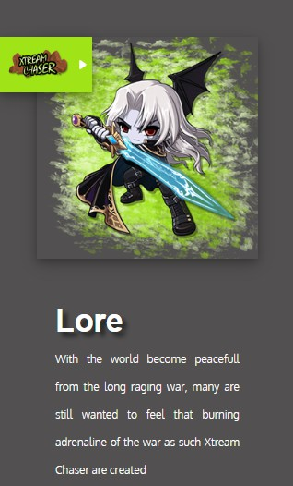

When its mobile mode its change the header into just logo at the corner where you can hover or tap to drop down the menu

## Referensi

Website Asset

* <https://www.deviantart.com/maple-custome-makers/gallery/36490776/Backgrounds?>
* <https://www.kindpng.com/free/maplestory-png/>
* Icons made by <a href="https://www.flaticon.com/authors/freepik" title="Freepik">Freepik</a> from <a href="https://www.flaticon.com/" title="Flaticon"> [www.flaticon.com](http://www.flaticon.com/)</a>
* Icons made by <a href="https://www.flaticon.com/authors/roundicons" title="Roundicons">Roundicons</a> from <a href="https://www.flaticon.com/" title="Flaticon"> [www.flaticon.com](http://www.flaticon.com/)</a>
* Icons made by <a href="https://smashicons.com/" title="Smashicons">Smashicons</a> from <a href="https://www.flaticon.com/" title="Flaticon"> www.flaticon.com</a>

# Logo Asset

<https://www.freepik.com/free-photos-vectors/design> - Design vector created by macrovector - [www.freepik.com](http://www.freepik.com/)

Disiapkan Oleh,

*Prepared by,*

* **< 2201812570 > - < John andray william doney >**
* **< 2201782454 > - < Johandhy Kadari >**
* **< 2201835656 > - < Albert novanto pratama jayadi >**
* **< 2201736813 > - < Kelvin Ferdianto >**